# Lab 1: Introduction to JMP

## Objectives

* Familiarizing yourself with JMP
* Analysis of data with one variable in JMP

## Recitation/Labs

The weekly recitation/lab sections are integral to the ChE320 course to learn how to apply the concepts that are introduced in lectures. In general, first hour of recitation is for working on the lab and the second hour can be used to work on your week’s homework with your group or to finish up the week’s lab, or they can be used as an office hour to ask your TA any questions you have.

**Labs are graded are on a 1 point system: if you show up and work hard on the lab (you don’t necessarily have to have everything correct), you get your point.** If you show up but don’t finish a good portion of the work, or you don’t show up at all, you don’t get the point. Make sure to put all of your answers to the lab in one place when you show them to your TA for grading: either make a Word document, create a JMP journal (explained below), or write them down by hand. These points are included in the 20% “recitation/homework” portion of your grade.

## JMP

JMP is statistical software that we will use in almost every lab this semester. It’s pretty intuitive to use and makes it very easy to do statistical analysis quickly and efficiently, and therefore it’s easy to plug in data and analyze it without considering the calculations that the software is doing for you in the background. **For the purposes of the homeworks, you can generally use JMP for analysis as long as you understand and explain your answers; but for the exams, make sure you understand all of the equations and calculations, since you won’t be able to use JMP.**

### Accessing JMP

On FRNY lab ECN machines, you should be able to find the JMP software in the Start Menu under 'JMP' or under 'ChE Software > JMP'. On ITaP machines (or on the ITaP [Software Remote](https://goremote.itap.purdue.edu/Citrix/XenApp/auth/login.aspx" \t "_blank) website), JMP can be found in the Start Menu under 'Standard Software > Statistical Packages > JMP'.

### Loading data in JMP

In JMP, you can either enter data manually (by clicking New Data Table and entering it like how you would in Excel) or import data (by clicking Open Data Table). **If you import data from Excel, it has to be the 2003 version (with the .xls extension, not the .xlsx extension). Also, if you are importing an Excel spreadsheet, make sure you change the file type in the Open Data File window:**

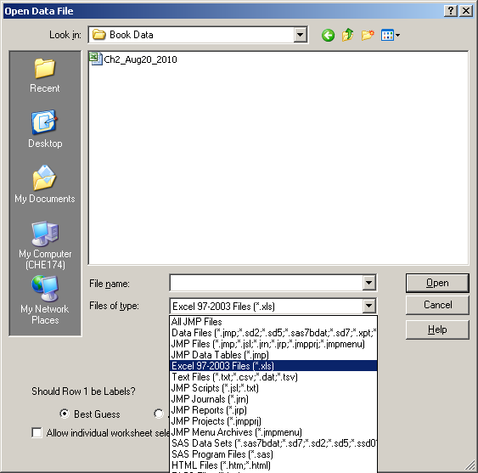

In labs, we will use data provided by the textbook, available at the [Student Companion site](http://bcs.wiley.com/he-bcs/Books?action=index&bcsId=6235&itemId=0470631473" \t "_blank) for the textbook. **Note that when you download data for a certain chapter, there are two separate sheets: one for the examples and one for the exercises.** They open as two separate tables in JMP.

### Analysis of data with one variable in JMP

**To analyze data that contains just one variable, we will look at the distribution of the data, found under Analyze > Distribution.**

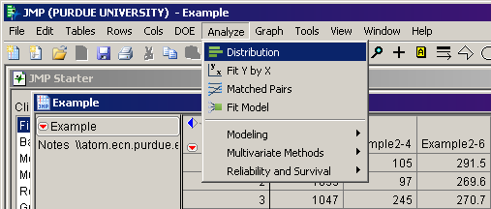

You can simply drag the column of data you want to analyze into the Y box. We won’t pay attention to the other optimal boxes.

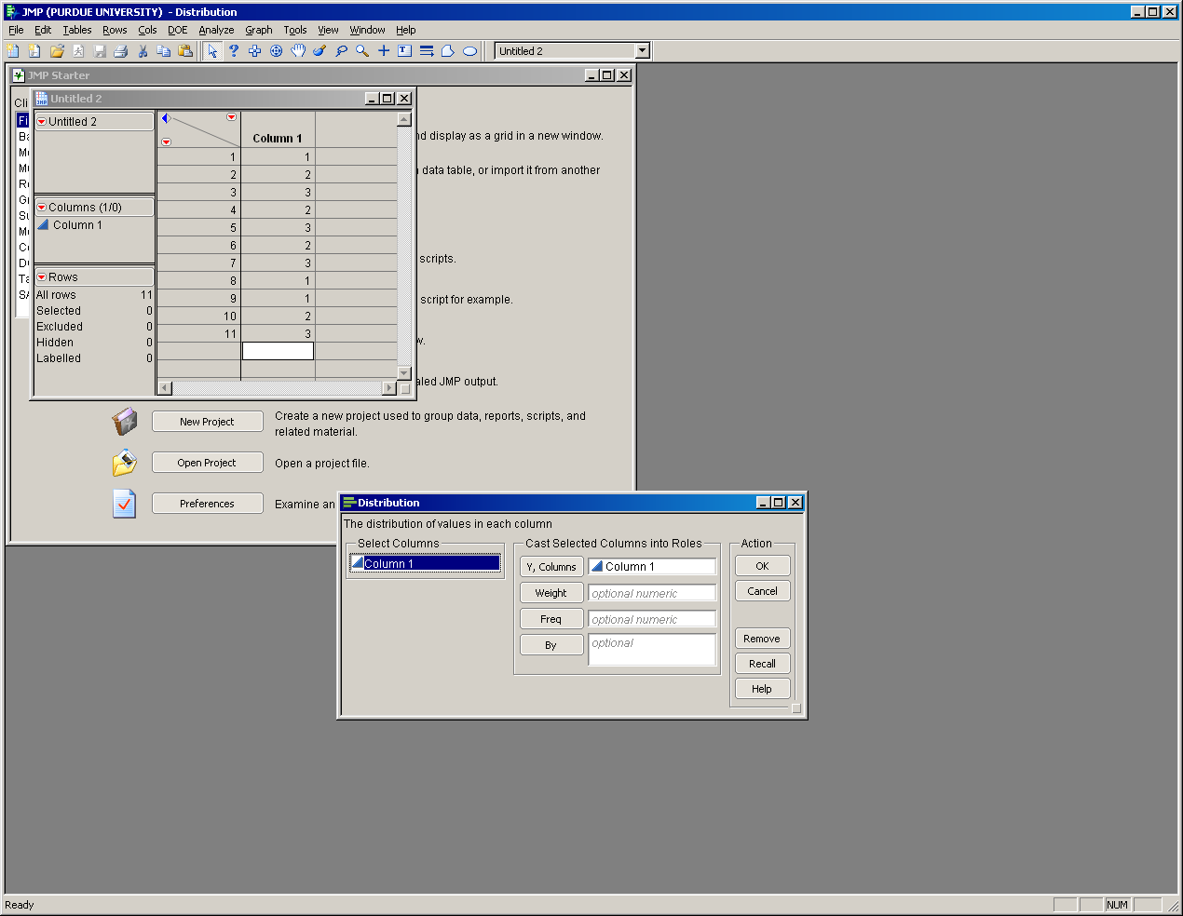

By default, this should give you a histogram, box plot, and some numbers below for median, quartiles, mean, and standard deviation. **In JMP, if you want more information than what’s given, you can always click the red triangle for more options.**

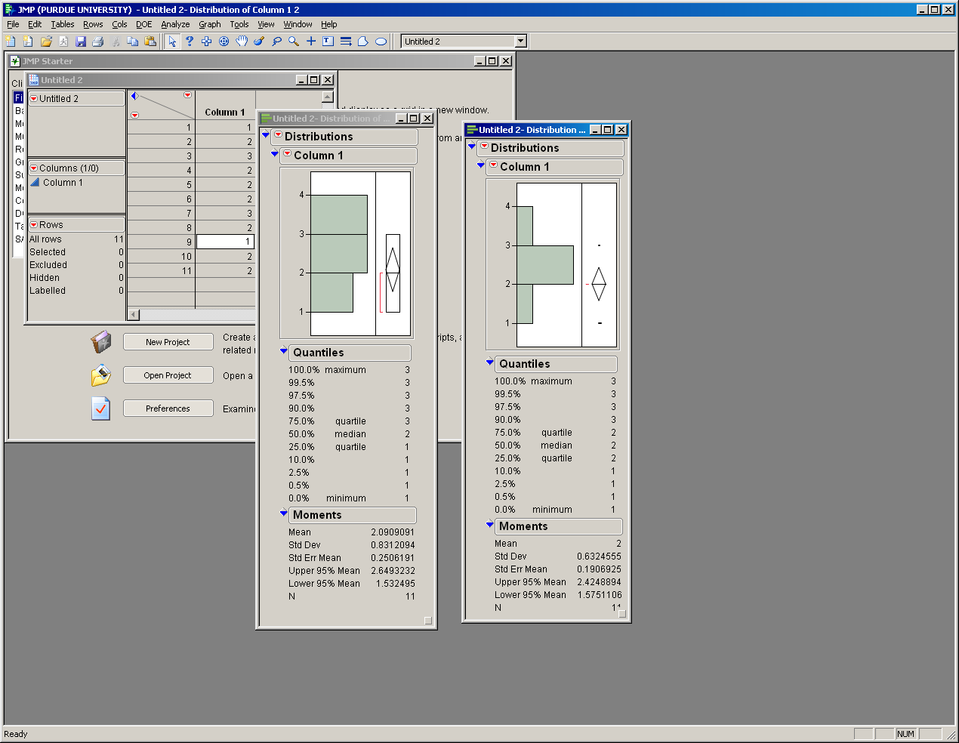

Lastly, let’s look at a few tools in JMP that will be useful to this class.



* *Journals*: You can save all of your data analysis in one window by hitting Ctrl + J when you have an output window (like the one above) open. That way, you will have one place with all of your answers. However, I do recommend that before you save something to your journal, select exactly what graph or table you want to save. For that, use the selection tool.
* *Selection tool***: If you want to pick only a subset of the output, use the selection tool (, available in the main toolbar) to click on a graph or table, then you can save that to your journal or copy and paste that into different software.**
* *Zoom tool*: Use the zoom tool () to look closer at graphs. To reset to the original setting, press Alt then click on the graph.
* *Annotate tool*: Use the annotation tool () to add your own text to the windows in JMP.

## Lab 1 Exercises

Using the data in column Example 2-4:

1. Find the mean, median, 25% quartile, and 75% quartile. What do each of these numbers represent?
2. Generate a histogram. What does a histogram show?
3. Add error bars and percentages to your histogram.
4. Generate a *horizontal* box plot. What is a box plot used for?
5. Generate a Stem and Leaf plot.
6. Name one way you might have used statistics in a previous class.